Parent Portal Login Guide
Please go to the following web link (our main website)
www.sidcot.org.uk and click on Parent Information or you can go to https://sidcot.fireflycloud.net/

Then click on My Portal
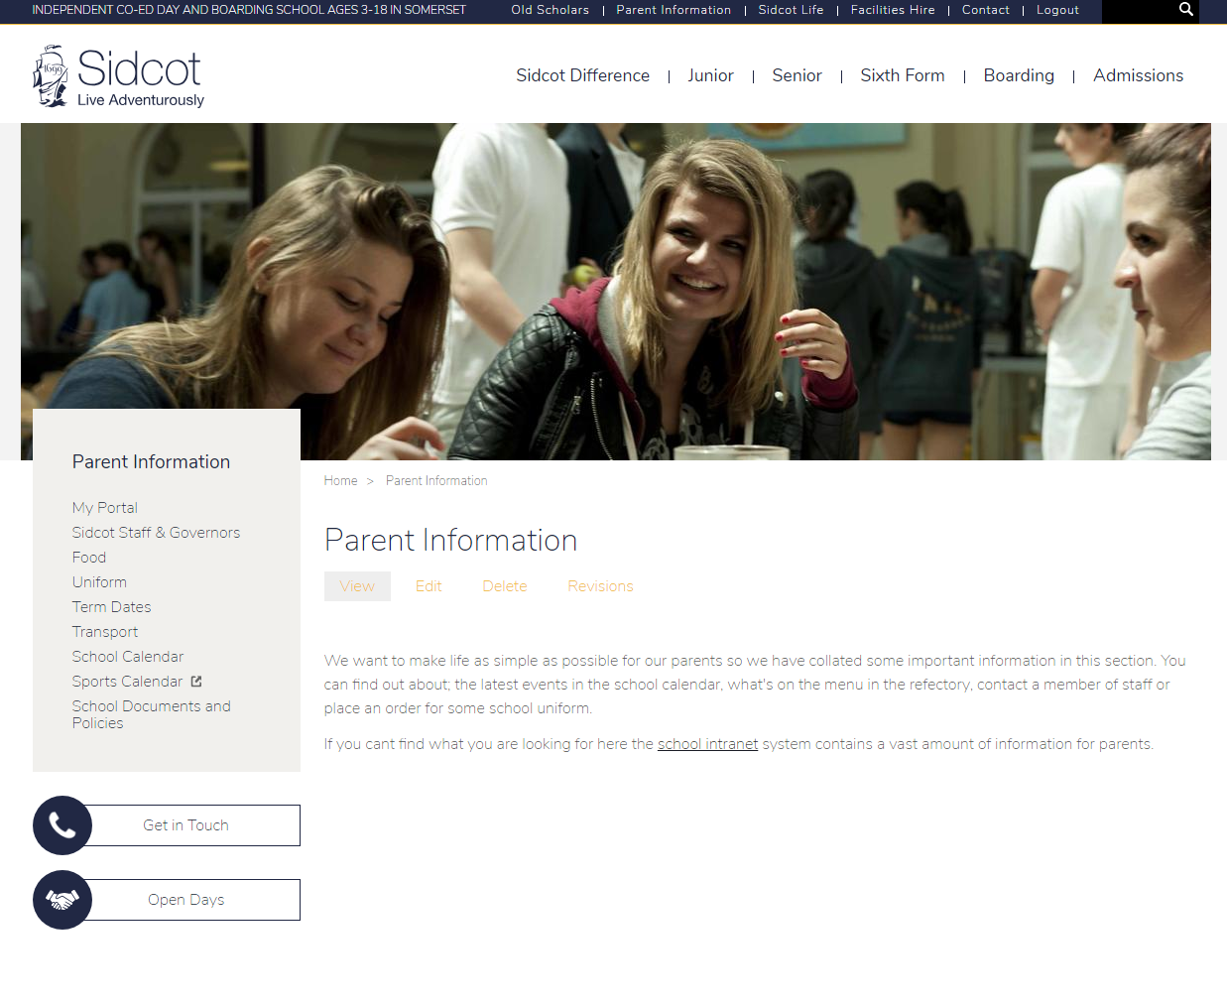
Then click on Parents
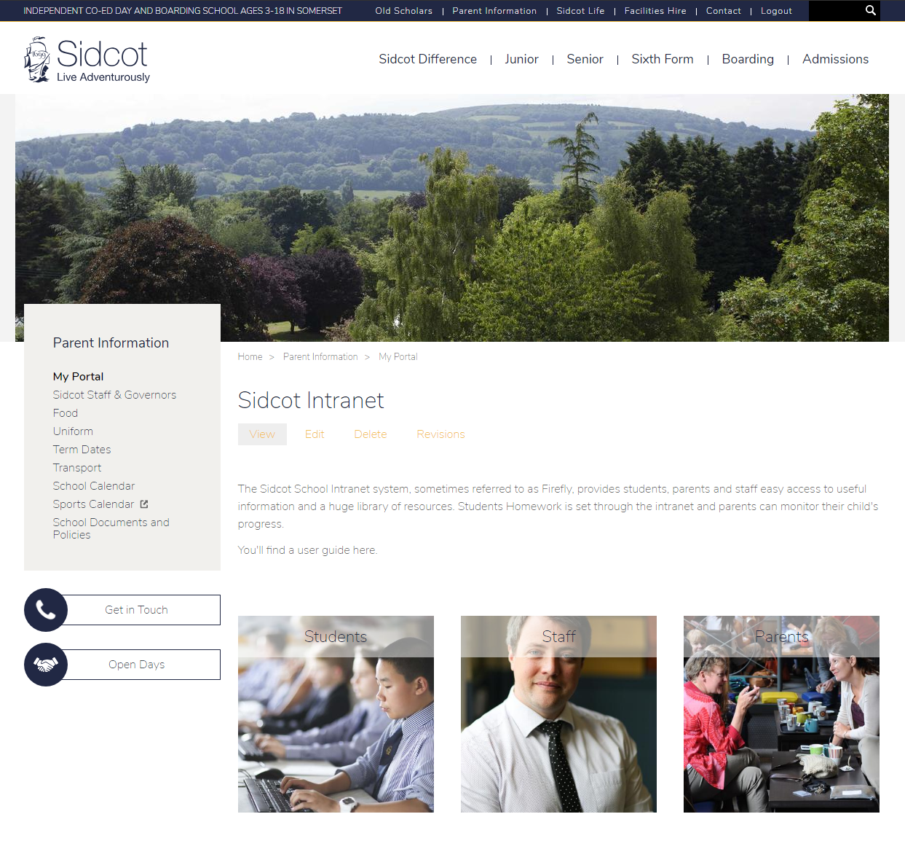
You will then see this login screen:
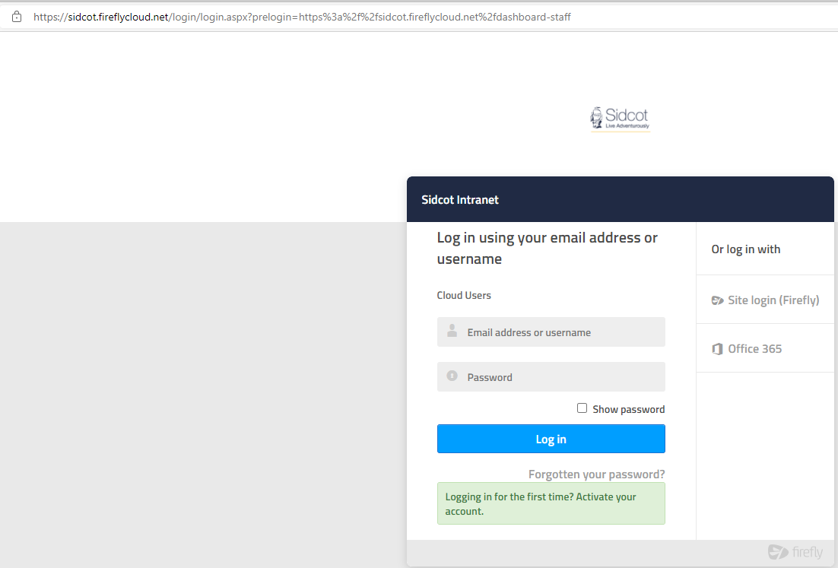

If this is your first time logging in please click on Activate your account at the bottom of the page
If you have already activated your account then enter you email address and password
You will then see a screen similar to this
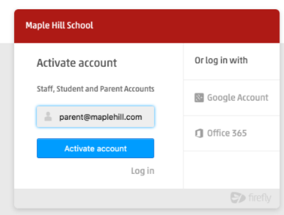
Enter your email address (the one you have registered with us)
You will then be sent an email, please follow the instructions sent to you

Once logged in you will see this:
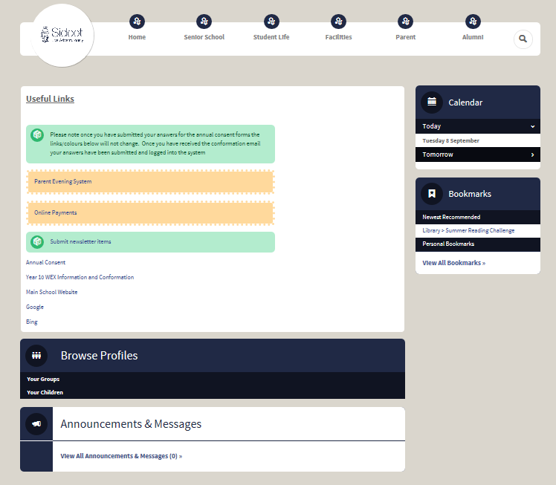
You will be able to see your contact details here
You will be able to change your details here
To see more information on your children

An example of what you might see, when you click on your children
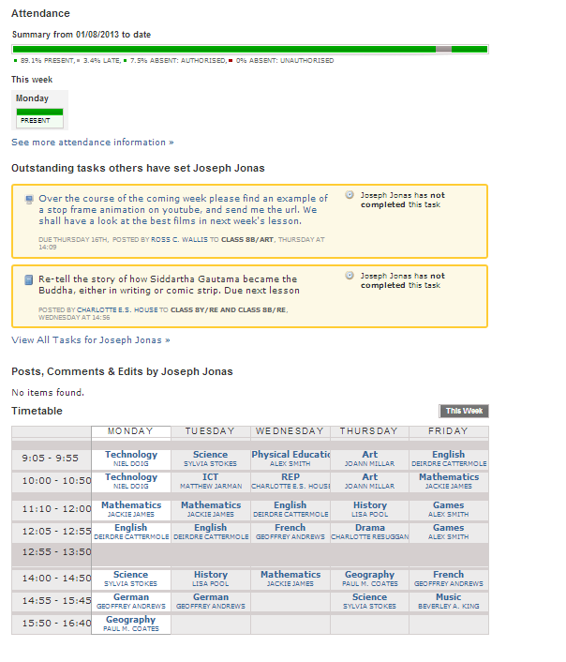
Their timetable
The prep work that has been set.
You will be able to see the currents weeks’ attendance

You can use the tabs across the top to find different departments and information e.g. Mathematics

If you have any problems or questions please email ITSupport.Parents@sidcot.org.uk

