AQA GCSE French Revision materials what and where to find them

- OneNote Modules - each Module has a vocabulary page.

- Our class page on Quizlet – each Module has a study set, plus there are extra grammar/tenses set – link to join class: https://quizlet.com/join/bGJbjuVyD

- Our Teams ‘Files’ section has a ‘Past Papers’ folder.

- a useful ‘listening’ website with short videos on all sorts of topics is thisislanguage.com
Activation codes below
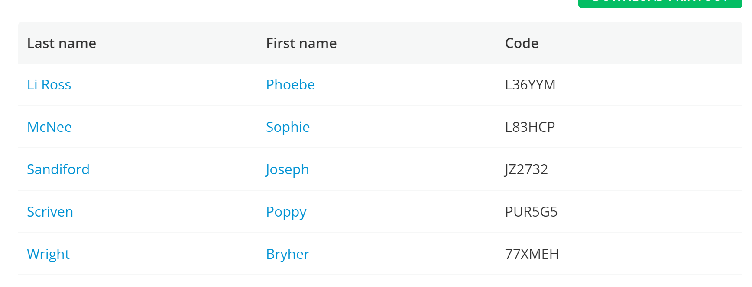

- Workbooks you purchased from school (3 different kinds): GCSE Knowledge Retriever books/ Revision book.

- GCSE Bitesize French AQA has all the themes with revision and practice pages as well as lots of grammar pages: GCSE French - AQA - BBC Bitesize

