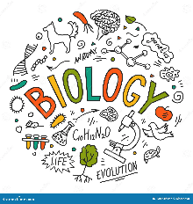**Combined Biology Guidance**

**Course:** AQA Combined Science – Biology

**Specification:** [AQA | GCSE | Combined Science: Trilogy | Specification at a glance](https://www.aqa.org.uk/subjects/science/gcse/combined-science-trilogy-8464/specification-at-a-glance)

**Use Seneca Learning website (your class teacher will have set you up in a team and set you some assignments**

**You have a CGP revision guide and workbook**

**You have access to the online text via Kerboodle.com (institution code= gz5)**

**Other useful websites:**

[Biology (Combined Science) - GCSE Combined Science Revision - AQA Trilogy - BBC Bitesize](https://www.bbc.co.uk/bitesize/topics/zthssrd)

[AQA GCSE (9-1) Biology Revision - PMT (physicsandmathstutor.com)](https://dev.physicsandmathstutor.com/biology-revision/gcse-aqa/)

[AQA GCSE Biology: Combined Science Revision Notes 2018 | Save My Exams](https://www.savemyexams.com/gcse/biology_combined-science/aqa/18/revision-notes/)

Primrose kitten YouTube channel