**Students have got lots of information in the revision folders in the OneNote notebook**

Specification: [AS and A Level - Biology A - H020, H420 (from 2015) - OCR](https://www.ocr.org.uk/qualifications/as-and-a-level/biology-a-h020-h420-from-2015/specification-at-a-glance/)

Past papers can be downloaded from here: [AS and A Level - Biology A - H020, H420 (from 2015) - OCR](https://www.ocr.org.uk/qualifications/as-and-a-level/biology-a-h020-h420-from-2015/assessment/)

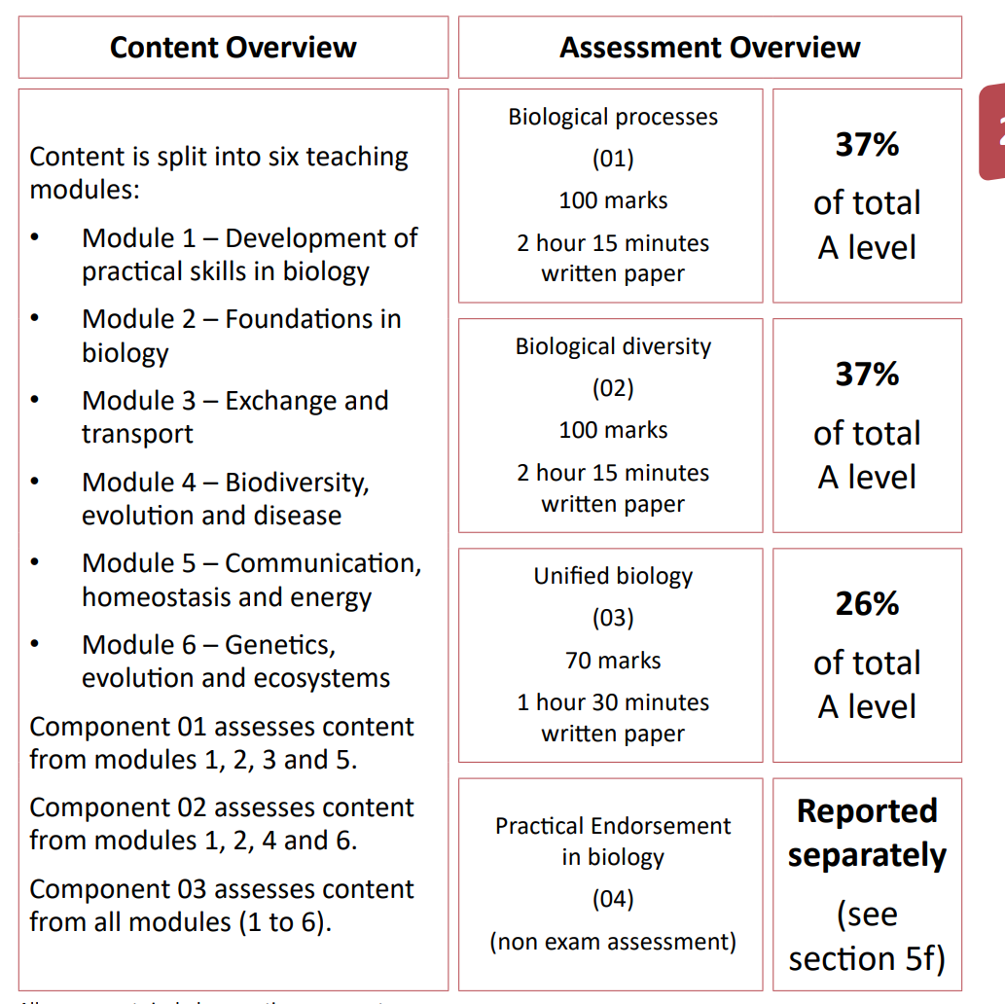

[Physics & Maths Tutor (physicsandmathstutor.com)](https://www.physicsandmathstutor.com/#) - paper and other revision resources can be found here

